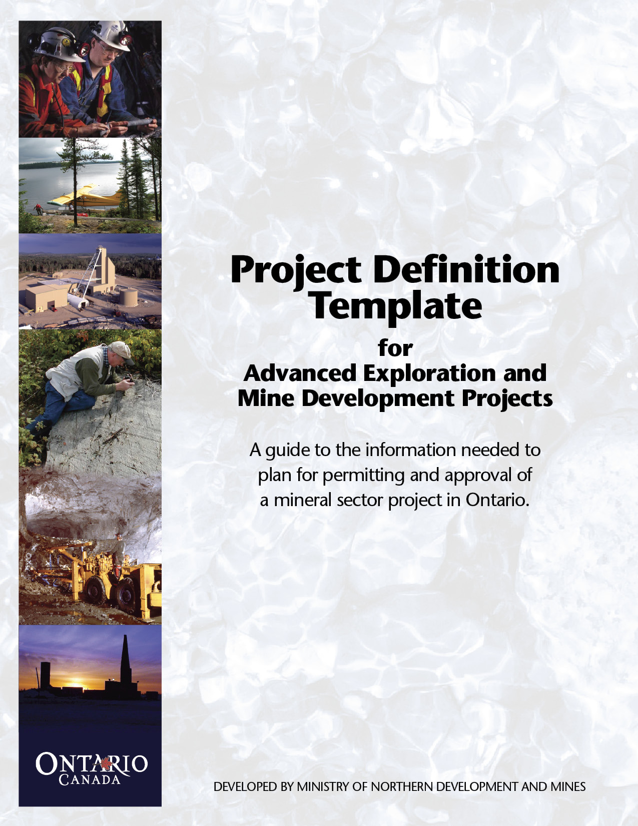
January 2010

Ontario Ministry of Northern Development amd Mines

Project Definition Template

Purpose

This project definition template is a part of the Ontario ‘One Window’ process for mineral development. It is designed to assist proponents in developing a detailed project description well in advance of commencing an approval process for a project.

The project description will be used to provide government regulatory agencies with a thorough understanding of the scope and magnitude of a proposed project. These government agencies can use this information to help identify and scope the potential regulatory processes, provide advice on issues and flag any new information required during the permitting and approvals stage.

The completed project description information will be circulated broadly within government departments and agencies. Using the project description, and through subsequent meetings or discussions, government agencies will work with the proponent to develop a detailed understanding of the applicable regulatory process, including for example, environmental assessment processes, permits, approvals, licences, information requirements, and public or aboriginal consultation issues. A list of potential regulatory agencies is provided on the back of this form.

Instructions to Proponents

This template is a suggested list of information items. It represents information that is likely appropriate for a wide range of projects, however it cannot be assumed to be a complete list of necessary information for all mineral development projects.
The list should be carefully interpreted by a knowledgeable person who can determine what information is applicable to the project in question, what level of detail is appropriate for the circumstances and what additional information, perhaps not listed, should be included.
Since it is highly recommended that a proponent commence discussions with government very early in the planning stages, it is recognized that not all of the suggested background information may be available at the time discussions are initiated. It is critical however, that sufficient information be provided to give a good understanding of the location, scope, and magnitude of planned development.
Location and land tenure are critical issues for permitting processes and may determine the nature environment assessment and approvals processes. The proponents’ land tenure situation and requirements should be well researched and understood. If environmental baseline data is available, the proponent should provide a high level summary of programs underway as well as results to date, focusing on key aspects of the environment that could be affected by the project. This is important in order to receive feed back on the adequacy of current or planned data collection programs.
An outline of all anticipated features and facilities at least at the concept level is essential. The proponent should outline where the uncertainties about the project lie and discuss alternatives under consideration. An outline of anticipated impacts, likely mitigation methods and technology used is highly useful and should also be presented if this information is known or available.

Legend
! | Section includes information that may be essential information for all projects
* | Information that should be summarized, if available, keeping in mind that it may become essential during the permitting process

IMPORTANT
- The proponent should work with the assigned Mineral Development Officer to develop required information packages.
- The number of hard copies of the document to be prepared should be determined in consultation with the Mineral Development Officer
- Please submit an additional copy in digital (PDF) format.
- Large, complex projects should prepare a report using the template as a guide to content and structure.
- Smaller, less complex projects may fill out this template and attach additional material when appropriate.

For Further Information

For further help with this template, please contact your nearest MNDM Mineral Development office:

Sudbury: 933 Ramsey Lake Road, 6th Floor. Phone: (705) 670-5827
Thunder Bay: Suite B002, 435 James St. S. Phone: (807) 475-1746
Timmins 1270 Hwy 101 East Phone: (705) 235-1627

Freedom of Information

The Proponent acknowledges that the Freedom of Information and Protection of Privacy Act, R.S.O. 1990, c. F.31 (FIPPA) applies to and governs all information provided in this submission and during the processing of the application and the permits, approvals and licences for the Project. Information in the custody or control of the Ontario government is accessible to the public under FIPPA, subject to certain specific exemptions. The Proponent acknowledges that any information provided to the Ontario government in this Project Definition Template may be disclosed if required by FIPPA or by an order of a court or tribunal or pursuant to a legal proceeding.

In addition, the Proponent acknowledges that the information being collected as part of the application and in the Project Definition Template is business and project information that MNDM will share with other Participating Ministries for purposes of processing the application. MNDM and/or the other Participating Ministries may contact applicants to obtain feedback on the process, to assist with improvements and program evaluation.

Table of Contents

1.0 Introduction and Summary 6

2.0 General Site Information 7

3.0 Land Tenure for the Project 7

4.0 Site Plans 8

5.0 Project Details 8

- Project Location Information and

Environmental Baseline Data 13

7.0 Project Schedule 16

List of Attachments 18

List of Potential regulatory Agencies 19

Sample Maps and Figures 20

Scope of the Project Definition

 | Topic |  |  |  | Project Information
 |  |  | Introduction and Summary
! |  |  | Name, address and corporate description of the proponent, and name, address and description of mineral owner, if different from project proponent  - Provide official company names  - Provide names of consultants/agents representing your company
! |  |  | The name(s) of any co-proponent(s), such as joint venture partner, corporation, government department or agency, municipality or other organization.
! |  |  | Summary of the purpose, nature and scope of the project  Note: This information is particularly important as it provides regulators with a clear and concise picture of the contemplated project and can thus aid in the speedy identification of potentially required permits and approvals. If the project relates to an expansion of an existing site then describe the percent increase in size or capacity from the original project.
! |  |  | Any consultations held regarding the project with federal authorities, provincial or municipal governments, Aboriginal groups, the public, etc?
! |  |  | Information identifying any federal government department or agency that is, or may be; granting federal land, providing financial support to the project (include indirect funding support, such as for infrastructure and training), or potentially granting authorizations
! |  |  | The name and contact information of one or two persons from whom government coordinator may obtain more information

General Site Information
It is suggested that photographs be included to illustrate key site features and work location.
! |  |  | Project Name
! |  |  | Previous Name (historical or alternate /operating names)
! |  |  | Current Status of the proposal (what stage of permitting/feasibility study - i.e. new / revised, expansion etc.
! |  |  | Ownership of Project (current and proposed)
! |  |  | Latitude/Longitude or UTM coordinates  (i.e. dd.d / UTM Zone NAD83
! |  |  | Geographic lnformation: description of location, and access to site (District/Township)
! |  |  | Site Address and Site Contact Information:
 |  |  | Land Tenure for the Project |  | Many permit and approval processes relate to the nature of land tenure where the proposed activity is located.  Provide a summary of the existing land tenure status of the project site, related facilities and infrastructure, including the status of surface and mining rights of patented or leased land. (Note: much of this information is best illustrated via site plans- See Section 4 and appendices):
! |  |  | Surface and mineral rights tenure (include proponent’s interest in the properties)?
! |  |  | Ownership of timber affected by the project?
! |  |  | Ownership of sand and gravel resources used?
! |  |  | Other neighbouring private land affected (potentially affected) by the project?
! |  |  | Crown land (Federal and Provincial) involved?
! |  |  | Indian reserves where facilities may be located?
! |  |  | Other easements and reservations and allocations, including forest resource licence holders etc?
 |  |  | Site Plans |  | Much of the information requested can be presented using site plans. Quality site plans at appropriate scales are essential and will assist the reviewers in getting a good understanding of the project and help you navigate the permits and approvals process faster. Sample plans are attached. Please attach site plans for your project
! |  |  | Regional Scale: e.g. Topographic setting, watershed areas, settlement areas, neighbours, infrastructure location, roads power lines, land use areas. Include property insert location sketch.  (See figure in Appendix attached)
! |  |  | Property Scale: e.g. topographic contours, water bodies and wetlands, data points such as : known hazard areas, monitoring locations, existing and proposed infrastructure, property boundaries, township fabric, land parcels with numbers, lots & concessions labelled, site location with regional insert sketch  (See figure in Appendix attached)
! |  |  | Site Plan: e.g. indicating the proposed location and arrangement and scale of, existing and proposed facilities. Identify land parcels  (See figure in appendix attached)
 |  |  | Project Details
 |  |  | Mining Activities
! |  |  | Any existing/previous development, operations and facilities?
! |  |  | Current status of the site (e.g. operating mine, inactive, undeveloped, advanced exploration, etc.)?
! |  |  | Targeted mineral(s), geology, and mineralogy  Any mineral resources identified?
! |  |  | Geochemical and geotechnical considerations. (e.g. potential Acid Rock Drainage and Metal Leaching characteristics, ground stability, terrain, overburden characteristics)
! |  |  | Proposed principle mining methods (e.g. underground vs. open pit; ramp access vs. shaft; equipment used, etc.)  Proposed major equipment and installations
! |  |  | Open pit / underground conceptual development plan with illustrations  (See figure in Appendix attached)
! |  |  | Proposed Haulage and handling operations (i.e. haul routes, crushing facilities; size and location etc.)
! |  |  | Proposed project duration and rate of mining
! |  |  | Major operational phases
! |  |  | Work force requirements and work schedule (i.e. construction, operations)
! |  |  | Processing  Describe any proposed milling, smelting, refining. Include a high level description of the proposed and existing facilities, location(s), the principle process and technology used, types of significant chemicals, additives and reagents used, major air emissions, waste generated and other environmental control technology.
 |  |  | Facilities and Infrastructure
! |  |  | Roads and Railways  Any expansions and/or improvements anticipated to existing public or private roads?  Any proposed new roads on crown lands, including their anticipated length, proposed route, water crossings, bridges and expected traffic?  Indicate if contemplated roads will be seasonal or all weather  Include a description of any new provincial highway alignments, new or existing entrances, encroachments and signage  Include description of new or existing rail lines and facilities and crossings
! |  |  | Any marine or inland water transportation routes and cargo carried?
! |  |  | Description of any contemplated port or dock facilities, including dredging requirements
! |  |  | Will any airfields be required and, if so, describe anticipated runway length and type and volume of air traffic
! |  |  | Power Supply:  What is the proposed method of regular power supply to the project?  - total electrical demand/consumption anticipated  - total generating capacity of primary use diesel generators  - standby generation facilities/ capacity  - length, capacity and proposed route of power transmission lines, if any  - location of substations and connections to existing grid*  - onsite power distribution plan*
! |  |  | Any fuel, natural gas or other pipelines anticipated, including their capacity, length, proposed route and whether any water crossings will be required
! |  |  | Any anticipated dams, dikes and diversions or other facilities in or near water bodies planned, or potentially needed?
! |  |  | Will any major buildings and large equipment be needed?
! |  |  | If a camp and associated services are required, include a description of the:  accommodation capacity  water, sewage and waste facilities  other facilities (e.g. medical, fire)
! |  |  | Will there be any aggregate requirements and, if so, describe any proposed pits, quarries Including;  Anticipated annual production requirements, and whether material will be collected from above or below the water table*
! |  |  | Storage Sites-  Describe the following:  Petroleum storage sites, including capacity, containment and handling facilities, fuel consumption,  chemicals, and reagents facilities,  hazardous or toxic substances facilities, storage  explosives facilities and storage
 |  |  | Tailings, Waste Rock and Other Mine Stockpiles
! |  |  | Anticipated production rates (tonnes, cubic metres per day/year?)
! |  |  | Proposed disposal location, method and treatment necessary
! |  |  | Expected size, physical and chemical nature of the all waste and stockpiles
! |  |  | Summarize any previous operation experience and performance, if applicable
! |  |  | Overview of any metal leachate, acid rock or other appropriate survey that is underway or proposed *
! |  |  | Water Management
! |  |  | Water Taking Requirements  Provide a description of anticipated water taking requirements including; uses, rates, sources intake locations and any known impacts or other considerations. (e.g. include mine/pit dewatering, pump test, process, cooling, potable water or other significant taking, removal, transfer or storage of water in excess of 50,000 l/day)  Describe potential impacts to ground and surface waters resulting from proposed water taking and indicate and if mitigation is believed necessary *  Summarize any previous operation experience and performance, if applicable  Provide an overview of any groundwater monitoring or model programs planned or underway*
! |  |  | Water Treatment and Disposal Requirements  Provide a description of anticipated major waste water treatment systems, e.g. mine water, storm water, industrial and domestic sewage, sediment and clarification ponds, coolant water  Describe or illustrate the anticipated physical facilities for such systems. (e.g. treatment process ponds, dams, pipelines, ditches, discharge locations, sampling points etc.)  Indicate the expected performance, including an estimate of effluent quantities and qualities and parameters of concern*  What is the anticipated impact on receiving water? *  Summarize any previous operation experience and performance, if applicable
! |  |  | Waste Disposal and Management Systems  Describe the nature of any solid, liquid or gaseous wastes likely to be generated by the project. What are the anticipated disposal procedures for any toxic/hazardous materials to be used or by-products of the project?*  Anticipated production rates of these materials?*  Anticipated handling, disposal locations and methods?  Summarize any previous operation experience and performance, if applicable
! |  |  | Closure and Rehabilitation  Describe any closure and rehabilitation considerations  Summarize any previous rehabilitation and performance, if applicable
 |  |  | Project Location Information and Environmental Baseline Data
 |  |  | Current Land Use
! |  |  | Describe the current land use(s) (e.g., mining, agricultural, traditional, recreational, industrial etc.) at the project site and in the adjacent area
! |  |  | Provide any information on previous activities on the site, including potential for contamination or hazards from past land use
! |  |  | Are there any neighbouring land uses and occupants?
! |  |  | Indicate the proximity of the project and related facilities and infrastructure to potentially affected Aboriginal communities, Indian reserves and lands that are currently used or have been traditionally used by Aboriginal people or Metis?  Describe any proposed archaeological or Traditional Ecological studies*  Describe the project proximity to any land claims, if known. *
! |  |  | Indicate the project proximity to important or designated environmental or cultural sites, such as national parks, heritage sites, historic canals, Areas of Natural or Scientific Interest (ANSI), and other sensitive other protected areas
! |  |  | Indicate the project proximity to recreational, residential and other urban areas
! |  |  | What is the current municipal zoning/designation of the proposed site/ related facilities and adjacent areas?
 |  |  | Environmental Features and Baseline Information | Provide a summary of the physical and biological components in the area likely to be affected by the project, such as terrain and topography, wetlands, water, air, noise, vegetation, fish, fish habitat, wildlife and wildlife habitat (including migratory birds) as follows. Identify Valued Ecosystems Components (VEC) if possible:
* |  |  | Topography and Landforms  (See figure in Appendix attached)  Provide a summary of the physical setting and components in the area likely to be affected by the project, such as terrain and topography, special landforms climate etc. attach maps as necessary
* |  |  | Terrestrial Plant and Animal Life Communities  Provide any information characterizing terrestrial plant and animal life communities in the project area. For example, include known rare, threatened or endangered species, migration routes, nesting areas etc in relation to the project.  Provide an overview of existing or proposed biological monitoring programs  Include the maps with locations of sampling or survey points as necessary.  Describe methods and frequency of monitoring, the biological communities to be monitored  Attach any maps showing these areas, if available
! |  |  | Surface Waters Information  Provide any information characterizing surface waters that may be affected by the project, including information on the existing quality and quantity of surface water and existing uses, if available*  Provide a description of freshwater/marine environmental features in the area*  Provide a Map of the watershed area showing water bodies and any existing or proposed sampling sites!  (See example in Appendix attached)  Illustrate or describe the project proximity to water bodies (freshwater and marine) (e.g., water bodies including names of watercourses, coastal areas, etc.) !  Describe or illustrate the physical characteristics of the waterway, i.e., length, width, depth, seasonal flow and fluctuations*  Provide any information on fish and fish habitat (e.g., fish presence and species, benthos) *  Provide a qualitative and quantitative description of the fish habitat *  Provide an overview of existing or proposed surface water monitoring programs including method and frequency of sampling*  Describe the existing use of the waterway and its navigability (e.g., kind, size and frequency of vessels, description of existing obstructions in the waterway) *  Provide any information on commercial, recreational or Aboriginal/subsistence fisheries in the area *
* |  |  | Aquatic Plant and Animal Communities*  Provide any information characterizing aquatic plant and animal communities in the project area. Include known rare, threatened or endangered species.  Provide maps showing these communities, if available  Provide an overview of existing sampling and/or monitoring programs including; method, location and frequency of sampling

Ground Water Information*

Provide any information characterizing the quality and quantity of ground waters potentially impacted by the project, including the identification of aquifers and existing groundwater uses on site and in the area

Provide an overview of existing or proposed groundwater monitoring programs including; method and frequency of sampling

Provide maps showing the current or proposed groundwater monitoring locations
* |  |  | Air Emission Information  Describe the nature of any possible emissions and the anticipated treatment technology/processes
 |  |  | Project Schedule
! |  |  | Describe the proposed overall development schedule, including; feasibility / engineering studies, permitting and approvals and construction schedule
! |  |  | Provide an overview of major construction issues and proposed schedule of development, include time of year, frequency, duration, special environmental engineering or access issues, resources and workforce required
 |  |  | Regulatory Processes and Schedule
! |  |  | Provide a overview of the regulatory process that is currently underway and what existing approvals are in place  Include an overview of any environmental assessment processes, approvals or licence requirements (federal, provincial, municipal) that the proponent believes may be applicable to the project
! |  |  | Include a list of ongoing or planned site and regional assessment work (with anticipated completion dates) to support the regulatory process. Include work such as:  Air, noise or dispersion model studies  Geotechnical and hydrogeology studies  Geochemical and metal leachate/acid mine drainage assessments  Water quality and hydrology studies  Benthos, fisheries and fish habitat studies  Hydrogeology, ground water studies  Terrestrial plant, wildlife and migratory birds surveys  Traditional Ecological Knowledge/ harvesting surveys  Cultural and Heritage values assessments  Archaeological assessments  Major mapping/remote sensing, aerial  Photography or orthophoto surveys etc.
! |  |  | Public & Aboriginal Consultation  Describe the level of public and or aboriginal involvement to date as well as a summary of major discussions, considerations and impacts and any planned future consultations  Provide a list of Aboriginal groups potentially affected by the project  Provide a list of stakeholders potentially affected by the project

List of Attachments

See list of potential government agencies and web address information
Sample maps/figures

Potential Regulatory Agencies Involved in Approval of Mineral Sector Projects in Ontario

Ministry of Natural Resources (MNR)
Ministry of Environment (MOE)
Ministry of Labour (MOL)
Ministry of Northern Development and Mines (MNDM)
Ministry of Transportation (MTO)

Note: Depending upon the nature and scope of your project, other agencies or ministries could be involved from time to time.

Sample Maps and Figures to help you Describe your Planned Mineral Sector Project in Ontario
